# Emergency Room Visits Dashboard Documentation

## Introduction

**Title**: Emergency Room Dashboard

**Purpose**: To provide insights on wait times, ratings score and other parameters like race.

**Audience**: Hospital Managers, Hospital Higher Officials

## 2.0 Dashboard Overview

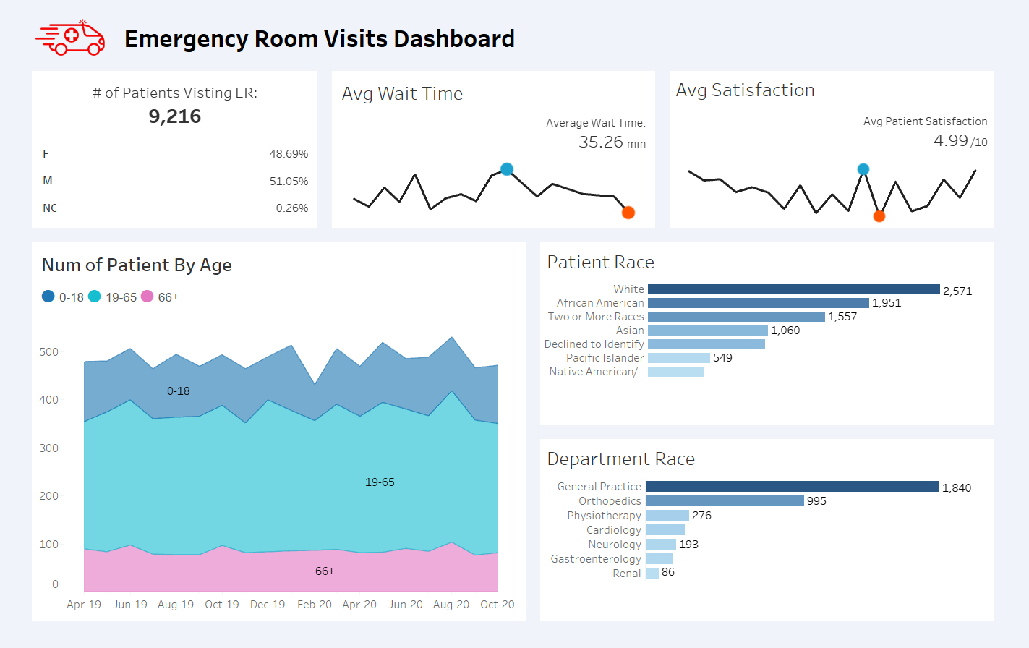

## 3.0 Data Sources

**Origin**: CSV File downloaded from data world

**Format**: CSV

## 4.0 Data Fields and Calculations

### Dimensions:

1. Date
2. Department
3. Patient Gender
4. Patient Id
5. Patient Last Name
6. Patient First Initial
7. Patient Race
8. Age Grouping (calculated field)

### Measures:

1. Patient Age
2. Patient Stats Score
3. Patient Wait Time
4. Min/Max Sat Score (calculated field)
5. Min/Max Wait Time (calculated field)

### Calculated Fields:

1. Age Grouping

For calculating Age grouping based of requirement.

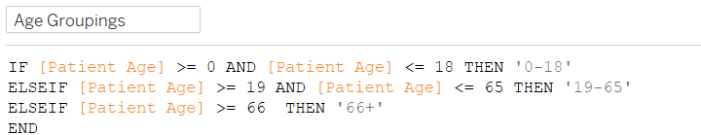

1. Min/Max Sat Score

For Calculating Min and Max point in line chart using dual axis for sat score i.e. satisfaction score.

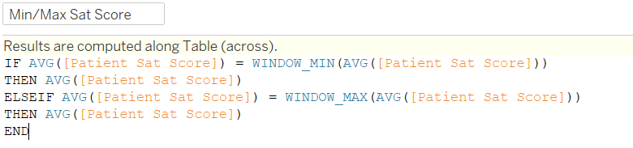

1. Min/Max Wait Time

For calculating Min and Max points on line chart for wait time using dual axis to indicate using circles.

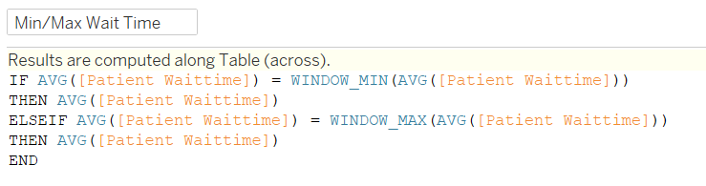

## 5.0 Filters and Actions

In this dashboard there are no filters yet.

Uses can filter clicking on Visualization:

1. Gender
2. Patient Race
3. Department
4. Line Chart i.e. (month-year) combination

## 6.0 Visualizations

### 1. KPIs

a. Breakdown of Total Patients by Gender

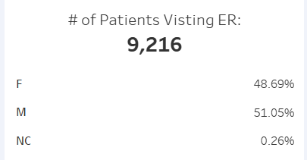

SQL Validation for this:

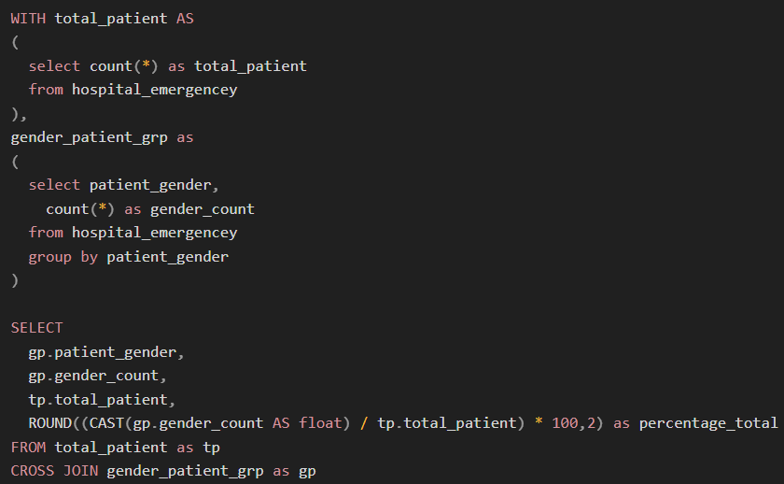

b. Average Waiting Time with Line chart ranging all dates available.

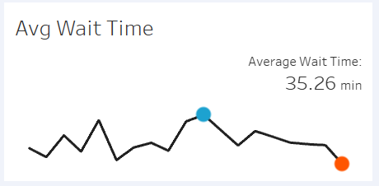

SQL Validation:

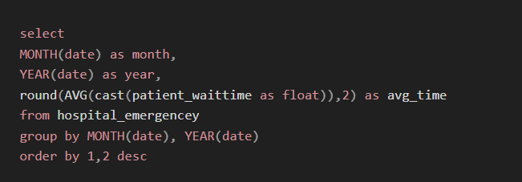

c. Average Satisfaction Score with Line chart ranging all dates available.

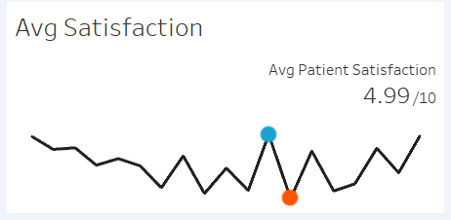

SQL Validation

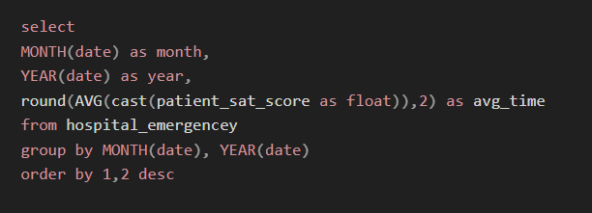

### 2. Number of Patient by Age Groups

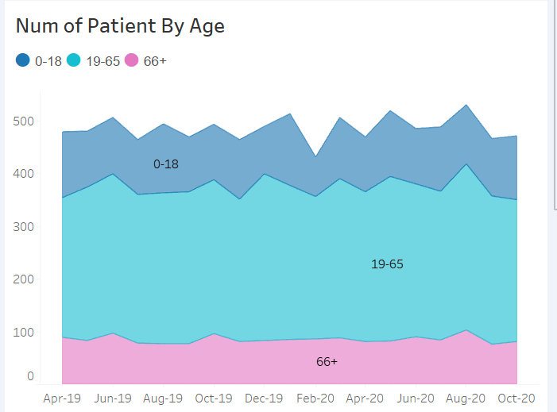

SQL Validation for Area Chart

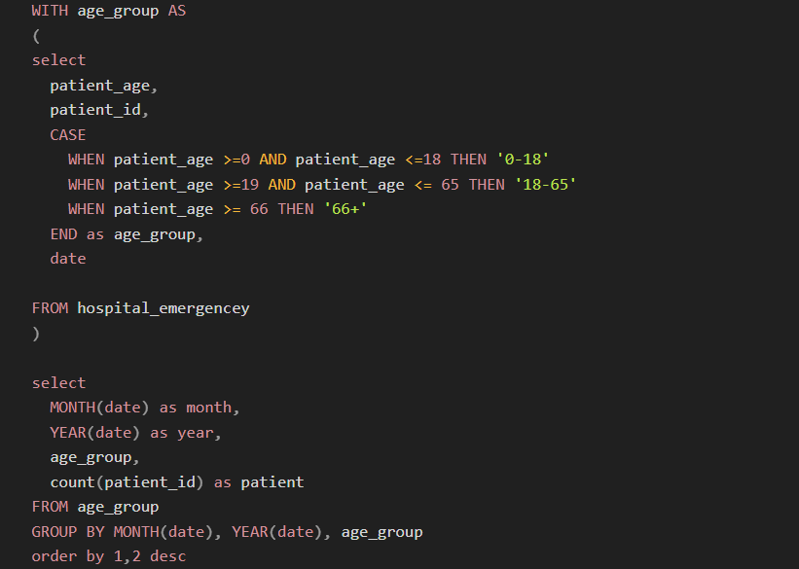

### 3. Number of Patient-by-Patient Race

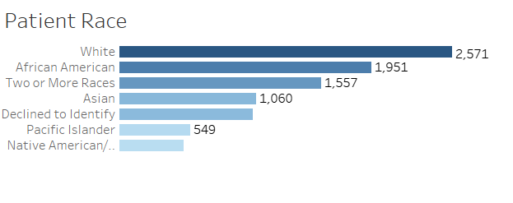

SQL Validation

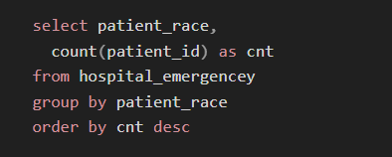

### 4. Number of Patient-by-Department

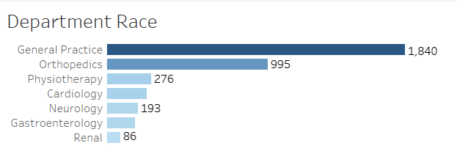

SQL Validation for Department Chart

